PEACE AND JUSTICE NETWORK
Presbytery of Grand Canyon March 2023
How Self-Development Can Become Locally Sustainable

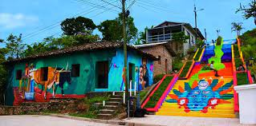
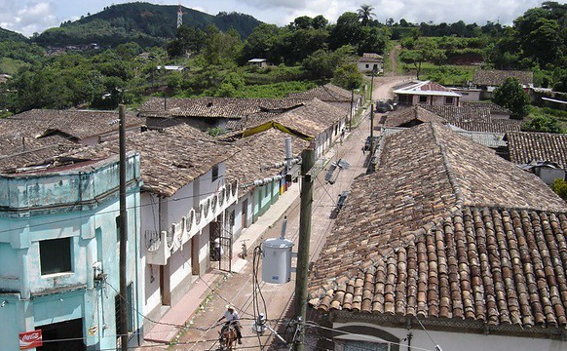
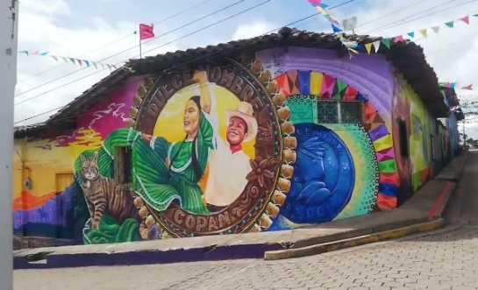
Dulce Nombre Before the Murals Walls Transformed Stairway to Heaven

Heifer International has long held the philosophy of “teach a person to fish” rather than giving them a fish. This philosophical approach has been implemented by the process of appreciative inquiry, in which participants engage in envisioning change that they see possible in their lives. Through this visualization, participants move toward a shared goal. During their years as lay missionaries in Honduras, Gloria and Tim Wheeler developed a very effective process for implementing appreciative inquiry in indigenous communities. When communities request a housing project, the first step is to meet with the community and listen; to appreciate and value what the community residents bring to the mutual work and encourage people to tell their history. Next, community members talk about the talents and values that have helped them along the way and start a process to build on these talents and values to envision the future. When a building project begins, the community once again voices the values they will use to do the work. As the Wheelers moved toward retirement, they began to identify ways for community building projects to continue. They focused on developing local coordination which would use the community-building methodologies that they had taught together with ongoing spiritual and financial support from North American churches. The local coordination and well-defined implementation methodology gave this mission process a character all its own of true accompaniment on behalf of the churches. Orangewood Presbyterian Church has been involved in the indigenous communities since 2008. The 15 years in which the mission teams have returned to the same areas have afforded the opportunity to continue the relationships and see growth and change. This year a new project will begin in Dulce Nombre (de Maria), a municipality that the mission team visited in 2022. The mayor and council of this town have added a new dimension in self-development. When they learned that having a block making machine was a gating item for a housing project, they undertook to develop a formal plan and agreement that included the use of the machine to make blocks that the town (or a private business) would purchase, for example for paving streets. The funds received from these other projects will be reserved for additional housing projects. In all other projects, the local municipality agrees to provide sand for the construction process while the North American teams provide funding for concrete, rebar, and roofing materials. This is the first town that will provide some of its own financial support.
The people of Dulce Nombre have big plans. They want to become a tourist attraction! To get things started, they held a festival in 2022 and invited muralists from all over Honduras to come to their town and decorate the walls of buildings. You can see the results for yourself in the photos below. The mayor and council are also actively promoting economic development for their youth. The mayor has donated all of his salary to a foundation that works toward this purpose. It will be interesting to see how it all turns out. Meanwhile, it is exciting to witness how the methodology of appreciative inquiry has taken root and expanded the scope of community self-development.

For more information about Honduras, Dulce Nombre, and the plans for the 2023 mission trip, contact Phebe Packer at phebepacker@gmail.com

