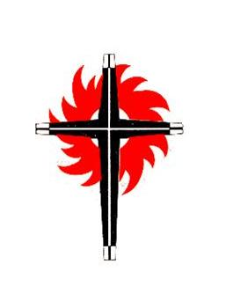

MEMORANDUM

TO: | Clerks of Session

DATE: | December 4, 2024
RE: | Annual Necrology Report

Please include the names of any Ruling Elders or Teaching Elders in your congregation that
passed away in this past calendar year. Return this form by January 15, 2025 to pby.rec.office@gmail.com for recognition at the January Annual Meeting of Presbytery.

Name of Presbytery ________________________________________

Name of Church ________________________________________

