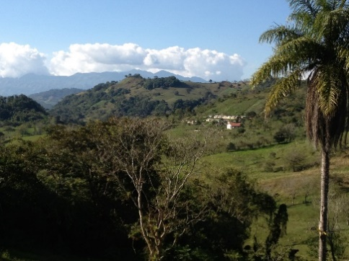
Teaming Up to Support Honduras Communities
Orangewood Presbyterian Church will join with members of other churches across the U.S. for a summer work trip in Honduras. The dates are set for July 6 – 19th 2024. The trip will have three components:
- Building houses side-by-side with community members. Orangewood has been contributing to a project in San Juan Planes in the municipality of Trinidad but our main focus for this summer’s trip will be in Dulce Nombre, where they are ready to begin a second build of 10 houses.
- Holding medical clinics to provide much-needed community healthcare.
- Meeting with community members in multiple locations to initiate and/or continue scholarship programs to help students continue their education beyond the 6th grade.
Orangewood invites all who are interested to join them this summer.
Orangewood began its annual trips to Honduras in 2008, developing a deep commitment to the appreciative inquiry process for community development and meaningful relationships in communities in the department of Copan. Over the past few years, a team of churches has formed - from South Dakota, South Carolina, Minnesota, and Arizona - who help each other support multiple projects. Each trip includes a visit to Copan Ruinas where the team visits additional communities and also has the opportunity to tour the Mayan ruins.
If you or someone you know would like to join this trip, please send Brent Upson an email at bwupson@gmail.com. If you or your congregation would like to contribute to the medical supplies needed for the clinics, this can be done at the following link:
https://www.amazon.com/registries/gl/guest-view/3JDFIRV1DY8R7
If you make a donation using this link, please do not change the shipping address. All supplies will be shipped to a partner church in Minnesota for transport.
If you or your congregation would like more information about the work in Honduras, team members would be glad to make a full presentation for your mission committee or other group within your congregation. Contact Phebe Packer at phebepacker@gmail.com.

