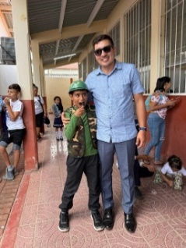
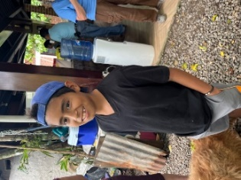
“Step Forward” is a new program being developed for providing shoes to children in elementary school in Trinidad, Copan. The program grew out of two stories coming together. Both stories feature young boys who stepped forward – literally, they stepped forward to tug on the sleeve of an adult. The first boy is Fernando who lives in San Juan Planes. The group from Unity PC in South Carolina encountered him in the summer of 2024. He came around the group as they were gathered for meals and although he didn’t say much, they learned that he was the orphan son of a woman who had been part of an earlier building project. She died in an accident that occurred in her house where fireworks were being made. Fernando lived with a relative but was largely forgotten and often hungry and alone. The group gave him some things and tried to get him to attend school. During this year’s trip, Fernando was more open and came closer to the group to communicate. Gloria Wheeler spoke with him and she and Joyce Sullivan from Unity PC approached Roger Pleitas about starting a fund to make sure Fernando received food. Roger is a prosperous young businessman who is instrumental in the building projects in the whole municipality of Trinidad. Roger said he never realized how poor some people in the area were until he met Fernando. Now they shop for food together and have developed a relationship with good back and forth communication. Roger offered to buy Fernando some shoes but Fernando said he already had shoes and what he really wanted was a military costume to march in the annual Independence Day parade through the town. Roger got him some things and they marched together. Fernando now goes to school, starting in the first grade even though he is 11 years old.
The second story is about a young father named Weldin who works as an assistant at a shoemaker’s shop in Trinidad. He has two step-children and one son. One day this past summer, Weldin’s step-son tugged on Gloria Wheeler’s sleeve and asked her if she had some eyeglasses. He said his father needed glasses because he had trouble seeing at night. Gloria called Weldin and he told her that he had been diagnosed with a diabetes related vision condition and could barely see at anytime of the day, not just at night. Gloria contacted Manos Amigos, a local non-profit dedicated to eye care and surgeries, and they said that there was someone there who could help with the type of problem Weldin had but he needed to come right away. So Weldin rushed over to Manos Amigos and they found that he didn’t have the diabetes related problem at all – he had cataracts! They have been able to do surgery, Weldin’s eyesight is restored, and now he is back to work at the shoemaker’s shop.
These two stories show us the importance of “stepping forward” to tug on someone’s sleeve and speak about your need – and also the importance of “stepping forward” to help when someone tells you their need. Through the years we have learned that many factors contribute to children being able to get an education in the rural communities of Honduras – can they afford the extra expenses when they continue beyond the 6th grade? Can their families afford for them to go to school instead of work as they get older? And for children of all ages, DO THEY HAVE SHOES? Our new initiative asks for contributions both here and in Honduras for shoes to be made at the shoemaker’s where Weldin works in Trinidad. We hope to provide 25 pairs of shoes (and socks) for the 2026 school year at a cost of $20 per student. Contributions for Scholarships and/or Shoes can be made to Orangewood Presbyterian Church, 7321 North 10th Street, Phoenix, AZ 85020. Put Honduras Scholarships or Honduras Shoes in the memo line of your check.

